**Name : Baljeet UID : 22BCS11134 Section : 605-B Assignment-6**

**Ques 1.** **Convert Sorted Array to Binary Search Tree.**

**Code:**

class Solution {

public:

TreeNode* sortedArrayToBST(vector<int>& nums) {

return constructBST(nums, 0, nums.size() - 1);

}

private:

TreeNode* constructBST(vector<int>& nums, int left, int right) {

if (left > right) return nullptr;

int mid = left + (right - left) / 2; // Middle element as root

TreeNode* root = new TreeNode(nums[mid]);

root->left = constructBST(nums, left, mid - 1); // Left subtree

root->right = constructBST(nums, mid + 1, right); // Right subtree

return root;

}

};

**Output:**

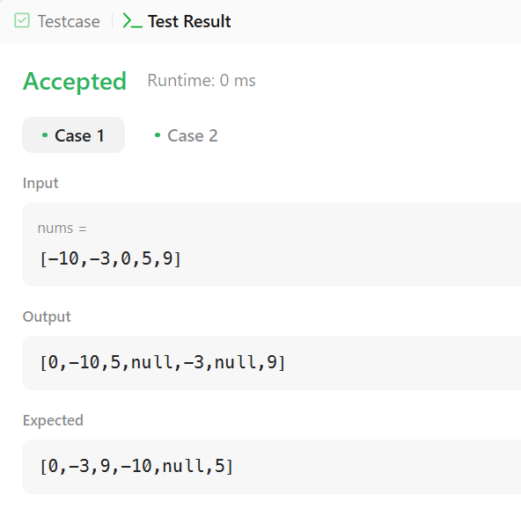

**Ques 2.** **Number of 1 Bits.**

**Code:**

class Solution {

public:

    int hammingWeight(int n) {

        int count = 0;

        while (n) {

            count += (n & 1);

            n >>= 1;

        }

        return count;

    }

};

**Output:**

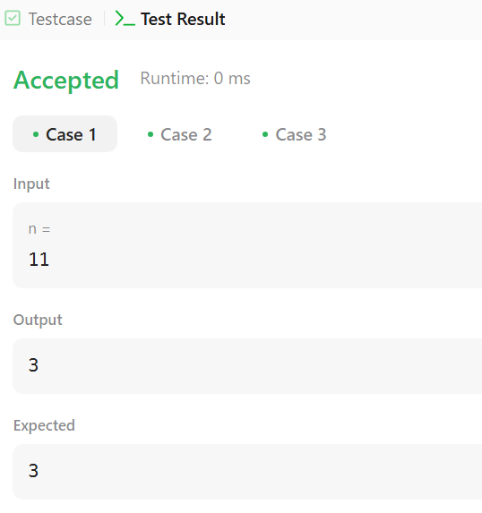

**Ques 3.** **Sort an Array.**

**Code:**

class Solution {

public:

    vector<int> sortArray(vector<int>& nums) {

        quickSort(nums, 0, nums.size() - 1);

        return nums;

    }

private:

    void quickSort(vector<int>& nums, int left, int right) {

        if (left >= right) return;

        int pivot = partition(nums, left, right);

        quickSort(nums, left, pivot - 1);

        quickSort(nums, pivot + 1, right);

    }

    int partition(vector<int>& nums, int left, int right) {

        int pivot = nums[right];

        int i = left - 1;

        for (int j = left; j < right; j++) {

            if (nums[j] < pivot) {

                swap(nums[++i], nums[j]);

            }

        }

        swap(nums[i + 1], nums[right]);

        return i + 1;

    }

};

**Output:**

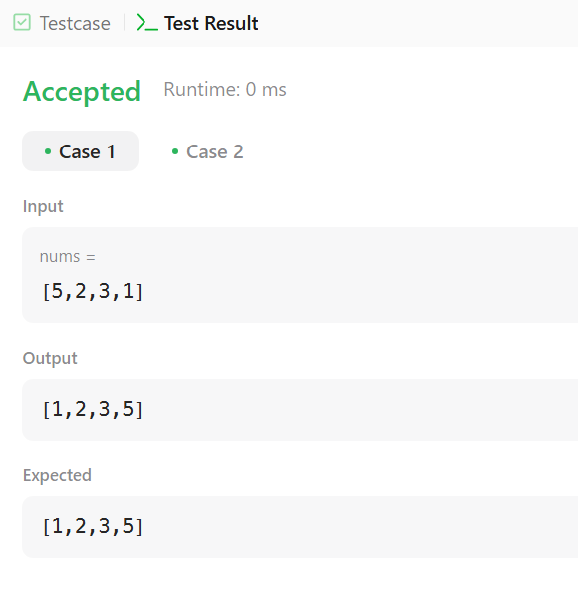

**Ques 4. Maximum Subarray.**

**Code:**

class Solution {

public:

    int maxSubArray(vector<int>& nums) {

        int maxSum = nums[0], currentSum = nums[0];

        for (int i = 1; i < nums.size(); i++) {

            currentSum = max(nums[i], currentSum + nums[i]);

            maxSum = max(maxSum, currentSum);

        }

        return maxSum;

    }

};

**Output:**

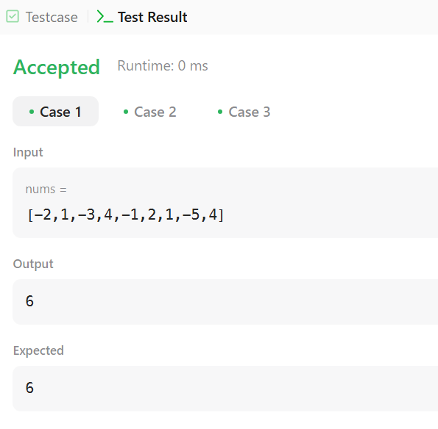

**Ques 5. Beautiful Array.**

**Code:**

class Solution {

public:

    vector<int> beautifulArray(int n) {

        if (n == 1) return {1};

        vector<int> odd = beautifulArray((n + 1) / 2);

        vector<int> even = beautifulArray(n / 2);

        vector<int> result;

        for (int num : odd) result.push_back(num * 2 - 1);

        for (int num : even) result.push_back(num * 2);

        return result;

    }

};

**Output:**

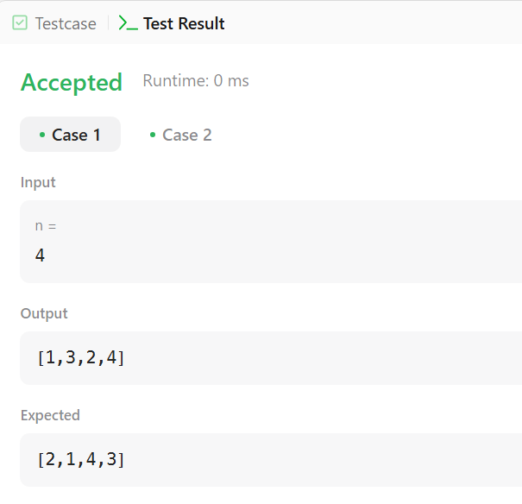

**Ques 6. Super Pow.**

**Code:**

class Solution {

public:

    const int MOD = 1337;

    int modPow(int a, int b) {

        int result = 1;

        a %= MOD;

        while (b > 0) {

            if (b % 2 == 1) result = (result * a) % MOD;

            a = (a * a) % MOD;

            b /= 2;

        }

        return result;

    }

    int superPow(int a, vector<int>& b) {

        a %= MOD;

        int result = 1;

        for (int digit : b) {

            result = (modPow(result, 10) * modPow(a, digit)) % MOD;

        }

        return result;

    }

};

**Output:**

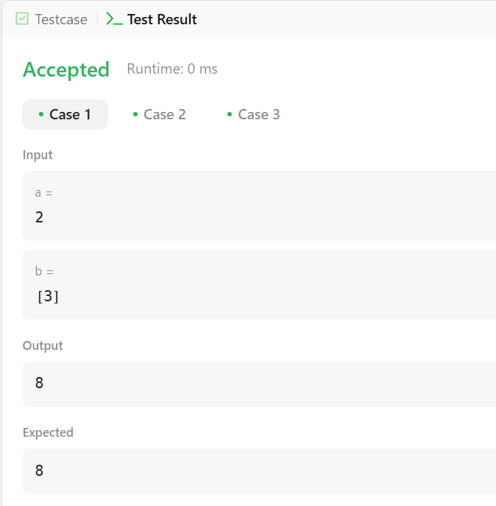

**Ques.7 The Skyline Problem.**

**Code:**

class Solution {

public:

    vector<vector<int>> getSkyline(vector<vector<int>>& buildings) {

        vector<vector<int>> result;

        vector<pair<int, int>> events;

        for (const auto& b : buildings) {

            events.push_back({b[0], -b[2]});

            events.push_back({b[1], b[2]});

        }

        sort(events.begin(), events.end(), [](const pair<int, int>& a, const pair<int, int>& b) {

            if (a.first == b.first) {

                return a.second < b.second;

            }

            return a.first < b.first;

        });

        multiset<int> heights;

        heights.insert(0);

        int prevHeight = 0;

        for (const auto& event : events) {

            int x = event.first;

            int h = event.second;

            if (h < 0) {

                heights.insert(-h);

            } else {

                heights.erase(heights.find(h));

            }

            int currentHeight = *heights.rbegin();

            if (currentHeight != prevHeight) {

                result.push_back({x, currentHeight});

                prevHeight = currentHeight;

            }

        }

        return result;

    }

};

**Output:**

